NAAN KHATAI

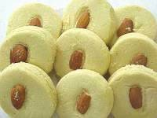

INGREDIENTS

250g butter
1cup oil
1 cup sugar
½ cup semolina
1 tsp elachie powder
1 tsp ground nutmeg
1 tsp baking powder
¼ tsp bicarb of soda
½ cup crushed almonds (optional)
2 ½ cups flour (plus little extra to form a soft dough)

METHOD

Cream butter and sugar well. Add oil and combine.

Add semolina, elachie powder, nutmeg, bicarb, baking powder and crushed almonds (if using). Mix well.

Lastly add the 2 ½ cups flour. Mix well. You may need to add more flour to form soft dough.

Make round ball shapes from the dough and place on a greased baking tray. Place a piece of almond in the middle of the ball and press down slightly.

Bake in a preheated oven of 180 degrees Celsius for 10 to 15 minutes or until light brown in colour.
COCONUT PAAK

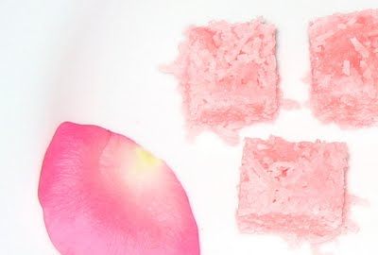

INGREDIENTS

1 tin condensed milk
500g dessicated coconut
500ml sugar
190ml water
5ml elachie powder
1ml rose pink colouring (or colour of your choice)

METHOD

Dissolve sugar in water, boil for 5 minutes.

Add condensed milk and cook until syrup is sticky.

Add elachie and coconut and beat for 2 to 3 minutes, until thick.

Divide mixture into two, press one half into a deep lightly greased tray. Add colouring to other half and press coloured mixture onto plain mixture.

Leave aside to set and then cut into squares.

CHANA MAGAJ
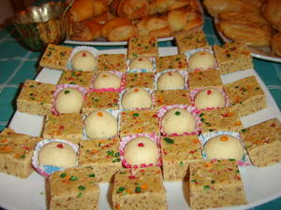
Ingredients
500g gram flour 1 ¾ cups solid ghee
500g icing sugar 1/3 cup cold milk
½ cup almonds-chopped 1 tsp elachi powder
1 cup klim almonds for decoration
Method
Melt ghee till hot. In a separate pot, sprinkle cold milk to gram flour to make the flour crispy.
Add almonds to flour mixture.
Add in the hot ghee & braise on medium heat, for about half an hour, or till magaj is well browned & almonds are browned.
Remove from heat, cool, and then add in the sifted icing sugar. Add in the elachi powder.
Mix well till magaj is soft. Add klim powder to magaj at this stage.)
Set as desired, & decorate with slivered almonds.
METHI LAGAN

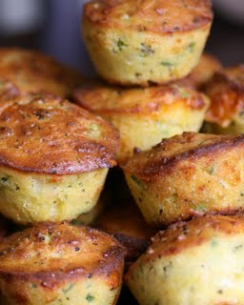

INGREDIENTS

1 bunch methi herbs
1 cup oil
1 cup milk
¾ tsp ground ginger and garlic

1 cup tastee wheat
1 cup gram flour
1 onion (finely chopped0
2 tsp salt
½ tsp tumeric powder
2 tbsp chopped dhania
½ tsp baking powder
2 tsp sugar
1 can cream style sweet corn

METHOD

Liquidize the first four ingredients together.

Add the rest of the ingredients to the liquidized mixture and mix well.

Pour into a greased pan or muffin pans and bake in a preheated oven at 180 degrees Celsius for 45 minutes.
PURIS

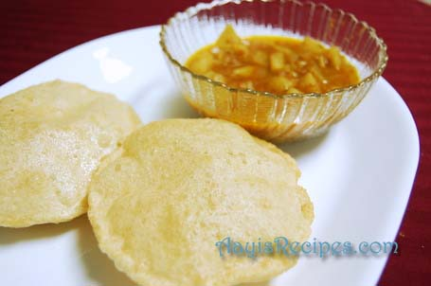

INGREDIENTS

2 cups cake flour
1 tsp baking powder
½ tsp salt
2 level tsp margarine
1 ½ cups warm milk

METHOD

Sift dry ingredients.

Rub in margarine.

Add warm milk to flour mixture and mix to form a soft dough.

Roll out and fry in hot oil.

Drain on paper towel.

CHANA MAGAJ
Ingredients
500g gram flour 1 3/4 cups ghee
500g icing sugar (3 1/4 cup) 1/3 cup cold milk
½ cup almonds-chopped 1 tsp elachie powder
1 cup Klim powder
Method
Melt ghee till hot. In a separate pot, sprinkle cold milk to gram flour to make the flour crispy.
Add almonds to flour mixture.
Add in the hot ghee & braise on low/medium heat, for about half an hour, or till magaj is well browned & almonds are browned.
Remove from heat, cool, and then add in the sifted icing sugar. Use your hand if it difficult to mix with a spoon. Add in the elachie powder.
Mix well till mixture softens. Add Klim powder and mix well. Set as desired, & decorate with slivered almonds.
Naan Khatai Biscuits
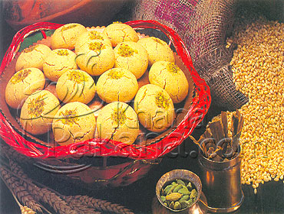
Ingredients
250g butter 5ml cardamom powder
1 cup oil 2.5ml ground nutmeg
250ml castor sugar 5ml baking powder
125ml semolina 3 cups cake flour (maybe a little extra)
2.5ml bicarbonate of soda ½ cup crushed almonds
Halved almonds for decoration
Method
Cream butter and sugar well. Add oil and combine.
Add semolina, elachie, nutmeg powder, bicarbonate of soda, baking powder and crushed almonds. Mix well
Add the flour gradually into mixture to make a soft biscuit dough. You may need to add more flour.
Make round ball shapes from the dough and place on a greased baking tray. Place a piece of almond in the middle of the ball and press slightly. Do not flatten the dough.
Bake in a preheated oven of 180 degrees C for 10 to 15 minutes or until lightly brown in colour. Store in an airtight jar
BURFI (with fresh cream)
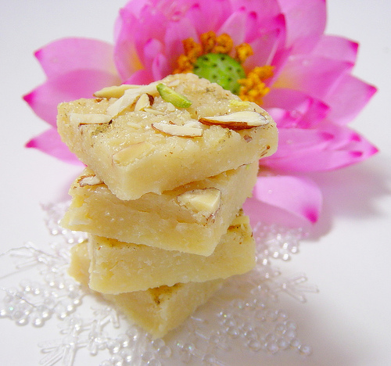

Ingredients
500 g Klim
250 ml fresh cream

Syrup

250 ml milk
625 ml icing sugar
50 ml ghee
125 ml sugar
5 ml rose water
2, 5 ml each elachie and nutmeg powder
Tinted almonds

Method
Mix cream and klim together. Set aside to dry for an hour. Sieve or use a food processor.
Combine milk, icing sugar, sugar and ghee in a pan. Simmer gently until you have a thread consistency. Add klim mixture and flavourings.
Cook until thick. Pour into a greased casserole or pan of your choice and sprinkle with almonds.
BURFI (with nestle dessert cream)

Ingredients
5 cups full cream powder / Klim
small can dessert cream

Syrup

½ cup milk
2 cups sugar
½ cup butter / ghee
5 ml each elachie and nutmeg powder
Tinted almonds

Method
Mix cream and Klim together. Set aside to dry for an hour. Sieve or use a food processor. You can also rub with the palms of you hands to get a breadcrumb effect.
Combine milk, sugar, and ghee in a pan. Simmer gently until you have a thread consistency. Add Klim mixture and elachie powder.
Cook until thick. Pour into a greased casserole or pan of your choice and decorate with almonds.
LUDDOO

Ingredients Syrup
825 ml gram flour 750 ml sugar
10 ml ghee 500 ml water
20 ml baking powder elachie powder
5 ml elachie powder colouring
5 ml egg yellow
Method
Combine all the dry ingredients to make a thick batter, by using water (similar to a fritter batter)
Boil the syrup mixture to make a thin, syrupy consistency.
Press the batter through a large hole cooking spoon or colander, held over hot oil.
Fry until golden brown. Remove from hot oil and dip into syrup. Allow to stand for 60 minutes, to cool.
Thereafter, mould mixture into balls. Decorate with coloured almonds and/or other nuts.

POLI

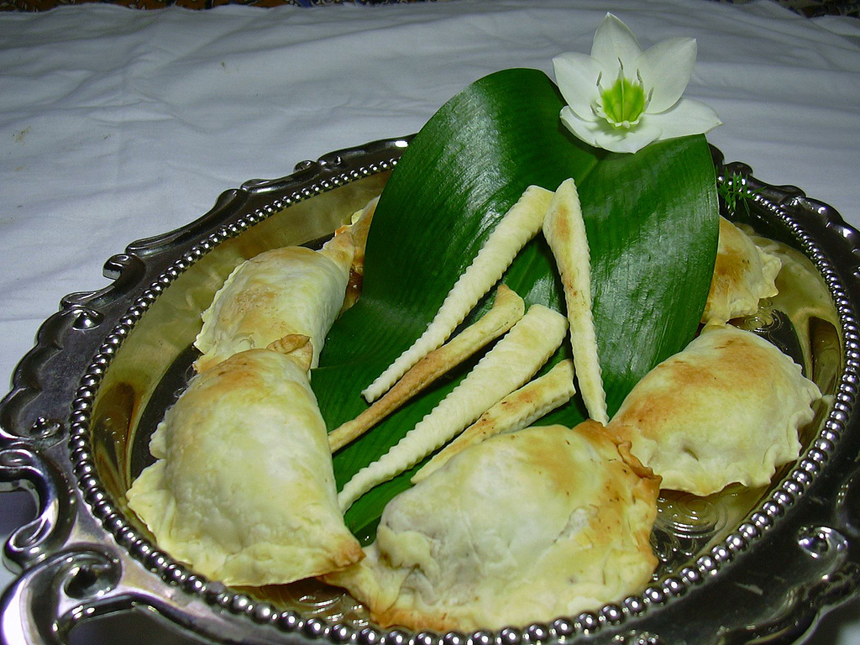
Ingredients
Dough Filling
500 ml cake flour 30 ml ghee
100 g butter 250 ml cream of wheat
225 ml milk 375 ml desiccated coconut
25 ml roasted sesame seeds
250 ml castor sugar
125 ml toasted chopped almonds/nuts Method
Dough: sift cake flour. Rub in butter until bread crumb effect. Add milk and mix to form a firm dough. Cover and set aside.
Filling: heat ghee and fry cream of wheat until golden in colour. Add coconut and sugar, fry until aromatic. Empty the mixture into a bowl and add the balance of ingredients. Mix well and allow to cool.
Roll puris and spoon a tablespoon of filling in the middle. Fold pastry in half and crimp the edges closed. Deep fry polis in hot oil until golden brown and crisp. Drain on kitchen towel.
Gulab Jamun
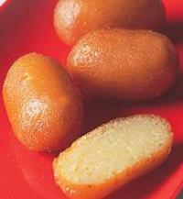
Ingredients
1 tin condensed milk Approx. 500 ml cake flour
100 ml water 10 ml baking powder
60 ml ghee Ghee/Oil for frying
5 ml elachie powder for syrup
2, 5 ml grated nutmeg 500 ml water
250 ml Klim 625 ml sugar
80 ml semolina 5 ml rose water
Method
Combine water, condensed milk, ghee and flavourings in a bowl and beat well. Add klim and semolina, mix well. Sift dry ingredients and add to liquid mixture gradually to make a soft dough. Divide into little balls and roll into finger shapes.
Fry slowly in ghee / oil until golden brown. Drain and dip in warm syrup. Drain on rack.
Syrup: dissolve sugar, boil for 15 minutes and keep warm.
Suji Laddoo (Soji balls)
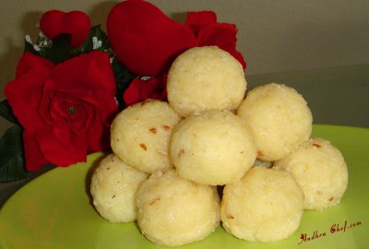
Ingredients
625 ml cream of wheat 2, 5 ml ground nutmeg
250 g butter 20 ml toasted sesame seeds
375 ml desiccated coconut 125ml toasted ground almonds
300 ml castor sugar 1/2 tin condensed milk
5 ml ground elachie pistachio nuts (crushed)
Method
Melt butter in a pot. Fry cream of wheat for 6 to 8 minutes until pink and aromatic.
Add coconut and fry until golden in colour, stirring continuously.
Remove from heat and then empty into a bowl.
Add elachie, nutmeg, sesame seeds, almonds, sugar and condensed milk. Mould into small ball shapes while the mixture is still warm.
Decorate with finely chopped pistachio nuts.
Mawa Ghari
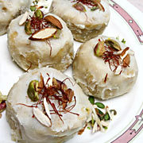
Ingredients Filling
Pastry 150 ml semolina
750 ml cake flour 125 ml desiccated coconut
30 ml ghee 500 ml klim
250 ml milk 25 ml ghee
1 tin condensed milk
Oil for deep frying 5 ml each ground elachie & nutmeg
Melted ghee for glaze 80 ml toasted almonds
Method
Pastry: sift flour in a bowl and rub in the ghee. Add sufficient milk and mix to a soft dough. Wrap the pastry in cling film and set aside.
Filling: heat ghee ad fry semolina until aromatic. Add coconut and fry until golden. Remove from heat and empty in a bowl. Add balance of ingredients and mix well.
Divide mixture into 20 portions and roll into round shapes. Divide pastry into 20 rounds. Roll rounds of pastry and enclose filling, pinching the edges.
Fry ghari on low heat until deep cream in colour. Drain on rack. Roll in melted ghee to glaze. Decorate with chopped pistachio and almonds.

Paneer sweet bhurji

Ingredients

- 1 L milk
- 1 cup sugar
- 2 cardamoms (powdered)
- saffron sprigs [optional]
- 2 tsp ghee
- 2 tsp lime juice

Method
Boil milk until creamy then add the lemon juice wait until the milk splits completely & again boil it for 3-4 minutes then cool it stain all the water using a tea strainer and now the paneer is ready.
In another heavy bottomed pan, add sugar then add the paneer that we had prepared then let the sugar melt.
When the sugar melts the paneer again becomes watery, let the paneer boil in the sugar syrup until reduced to half the quantity and the paneer slightly dry.
Now add the cardamom powder and ghee now fry it till the paneer is completely and forms into small balls like then cool and serve.

GRILLED HOT N SWEET PANEER

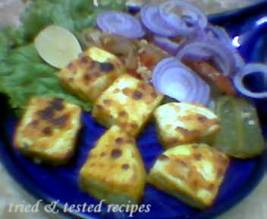
Succulent cubes of paneer, marinated in an oriental honey chilli marinade and grilled till the honey just about caramelizes, imparting an unusual flavour to this dish.
Ingredients

1 cup paneer (cottage cheese), cut into 25 mm. (1") cubes

4 spring onions (including greens), finely chopped

2 tablespoons honey

1 tablespoon chilli sauce

1 teaspoon lemon juice

¼ teaspoon lemon rind

3 cloves garlic, grated

1 tablespoon chopped coriander

1 tablespoon oil

salt to taste

Method

Combine all the ingredients in a bowl and mix well. Allow to marinate for at least 15 minutes.
Arrange the paneer cubes neatly onto 4 wooden skewers and grill them over a charcoal or electric barbeque till they are lightly browned on all sides.
Serve hot.

Rasgoola

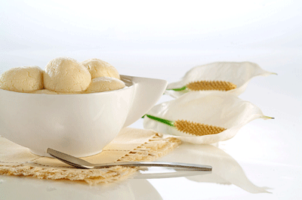

Ingredients
- 1 L milk
- 2 tsp white vinegar
- 1 1/2 cup sugar
- 3 cup water
Method

Bring the milk to a boil and add vinegar to the boiling milk to separate the whey. Throw away the liquid part by sifting the stuff onto a muslin cloth.

Pour some cold water over the curd to cool and wash it. Discard the water and hang the cloth for 15-20 minutes to let the excess water drip off.
Put the curd in a food processor or blender and blend at high speed to get a smooth consistency.
You may add just a little (1 tsp or so) water while blending, if the curd is too dry and will not blend. Be very careful so as not to add any extra water. Remove the paste and make small balls (1-2" in diameter).
Boil water in a wide vessel. Make sure that there is at least 2-3" of water in the vessel.
If not, add more water and increase the quantity of sugar proportionately. Add sugar to the boiling water to make a light syrup.
Continue boiling the syrup and gently drop the curd balls in the boiling syrup. Cook the balls in the boiling syrup for 30-40 minutes.
Remove from the heat and let the stuff cool down. Put the balls and the syrup in a storage container and refrigerate (don't freeze). Serve cold.

Rasgullas
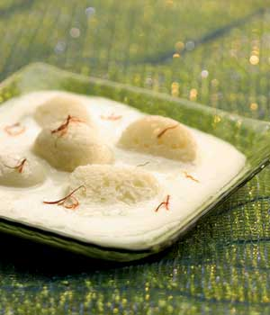
Ingredients
(Makes 12-14)
4 cups whole milk
2 tbsp of lemon juice
1-1/2 cups sugar
4-1/2 cups water
1/2 tsp cardamom powder
Method
For paneer
Boil the milk in a heavy bottomed pan over medium heat, stirring occasionally, making sure not to burn milk. As the milk comes to a boil, add the lemon juice gradually and stir.
When the milk solids separate from the whey, turn off the heat and drain using a strainer lined with cheesecloth. The milk solids left on the cloth is called paneer.
Rinse the paneer under cold water, and squeeze well. (This process takes out the lemon flavor from the paneer). Squeeze out all the water from the paneer. (To check if the paneer has reached the right consistency, take a little piece of paneer on your palm and rub with your thumb for 30-40 seconds.
After rubbing the paneer, you should be able to make a firm but smooth ball off it. If you cannot form balls, it means you will have to squeeze out more water from the paneer)
Once the paneer is drained, put it in the food processor and run it for about 15-20 seconds. (You will notice the paneer will first crumble and break into small pieces in the processor and then it slowly forms one big lump just like chapathi dough). As an alternative to using the food processor, you can knead the paneer with your hands. Place paneer on a dry, clean surface and knead it for 9-10 minutes until it comes to a smooth and pliable dough consistency. This takes a longer time. Knead the paneer well as you would do with chapatti dough (if the paneer is too crumbly, add a 1/8 teaspoon of water.)
For rasgullas
Divide the dough into 12-14 equal parts and roll them into round balls or pat them into flat discs(like I have done) with the palms of your hands. (The balls/discs should be smooth and they should not have cracks, otherwise they will break when they are cooked.)
Combine sugar, water and cardamom on medium high heat and bring to a boil. When the sugar dissolves, add the paneer balls and close the lid. (Make sure the cooking vessel is large enough to accommodate the finished Rasgullas, as they will double in size while cooking and soaking in the syrup). Turn the stove heat to high.
If you have made paneer balls, reduce heat to low and cook for about 2 additional minutes. Then turn off heat. If you have made paneer discs, then turn off heat (wait at least 7-8 minutes)
When the rasgullas are done they will be spongy. (There will be a lot of dilute syrup left in the pan) Don’t worry. Transfer only the rasgullas, carefully, to another dish. Then put the syrup, left in the pan, on low-heat and simmer it for 10-15 minutes till you get thicker syrup. Then return the rasgullas to this syrup and refrigerate it. Serve Rasgullas chilled.

Rasgullas Cheese Balls In Sugar Syrup
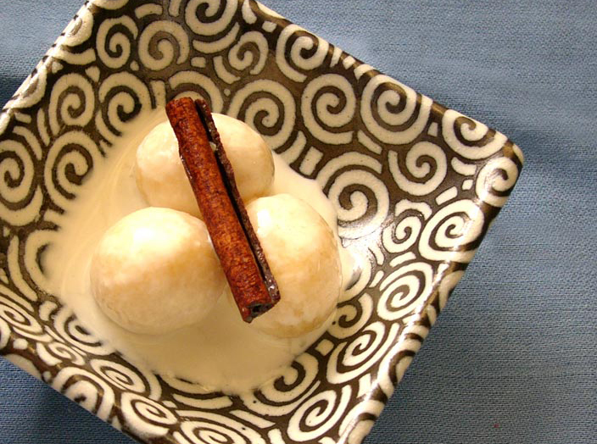
Rasgullas is an Indian sweet dish which is very easy to make and of course very tasty. It is usually made with Paneer (Cheese).
Ingredients
To make Cheese (Paneer) For Syrup
8 cups milk (full cream milk only) 3 cups of sugar
3-4 tbsp vinegar 6 cups of water
To make Rasgullas 2-3 ml elachie powder
Paneer (Cheese) from above method ½ tsp. rose water
2 tsp semolina or flour
1 tsp sugar
Method
Rasgullas (Cheese Balls in Sugar Syrup)
Boil milk and when big bubbles show up, stir vinegar in it and let it boil. The whey water and Paneer (cheese) will separate.
If you still see white liquid in it, it means you need more vinegar to add in it.
When it completely separated turn off the heat and strain it through a strainer.
Keep the cheese at least twelve hours so that all the water could be drained off of it. Your Paneer is ready for Rasgullas.
Sieve the cheese through strainer so that it could be softened and pliable.
Add semolina or flour and sugar and mash it nicely.
Divide in 25 equal portions and make balls.
The balls should not have any cracks in it. If you see any cracks it means the cheese is not soften enough.
If it sticks to your hands you can dust very little flour in it but be careful because more flour also can cause balls to break.
Meanwhile in a big pan add sugar and water and bring it to a boil.
Add all the balls in sugar syrup.
Cover it and let it cook for 30 minutes in high heat.
Add cardamom powder and rose water after 25 minutes of cooking.
Remove from heat and let it cool.
It tastes better when served chilled.

Paneer Burfi

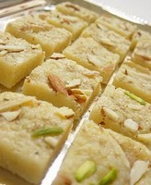
Ingredients
1-1/4 cup fine ricotta cheese
1-1/4 cups paneer
2 tsp ghee
½ cup fine sugar
Cashew nuts and pistachio nuts as toppings
kewra essence / vanilla essence
silver foil (Vark)
Method
Mash ricotta cheese and paneer well in separate dishes.
Heat ghee in a pan and brown or sauté.
After 2-3 minutes, remove the pan from heat and add mashed paneer to it.
Add sugar and nuts.
Add 2 drops of kewra (substitute with vanilla) to it and set the mixture in a flat dish.
Allow it to cool and apply vark.
Cut them to round or square pieces as desired and refrigerate for about an hour, then serve.

